Game Design Document:

Team Name: Rout

Team Members: Dan Hall, Nathan Palson, Alexander Jones

Game Name: Rout

Development Environment: (circle one) DirectX 10 DirectX 9c C# and XNA

Hardware Platform: PC

1. General Information
   1. Short Game DescriptionRoot is a 3D exploration game where the player is a man who is dropped in a maze. The player must navigate to the exit of the maze. Along the way the player can mark and light their path using torches. The player must also avoid the Wandering enemy patrols that will give chase and defeat the player if they catch them. The player cannot stand against the enemies, so he can avoid them or out maneuver by teleporting back to a previously set point that he placed along the path way.
   2. More Detailed Description

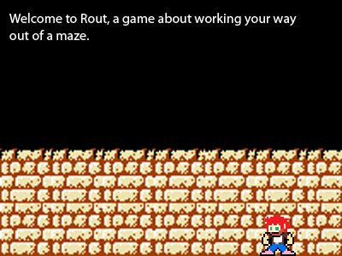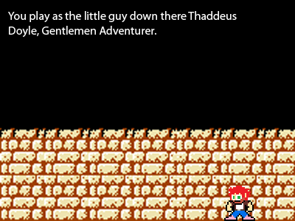

*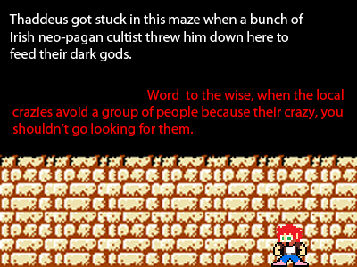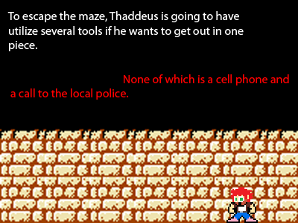*

*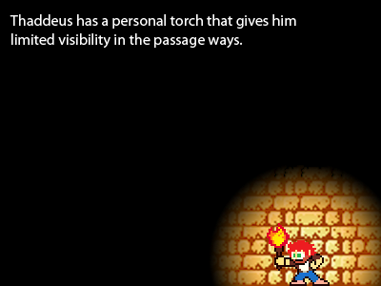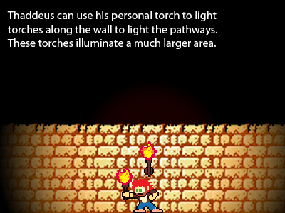*

*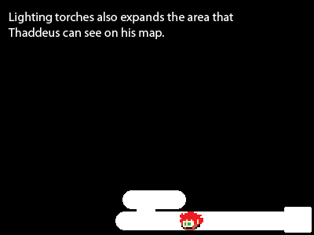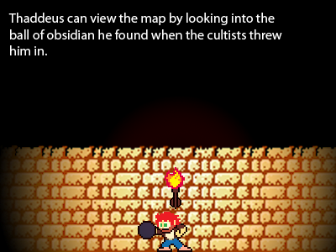*

*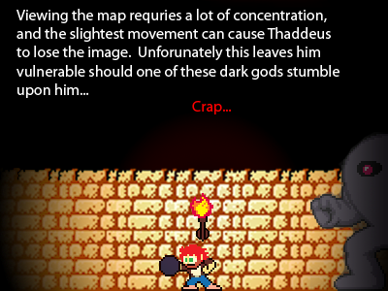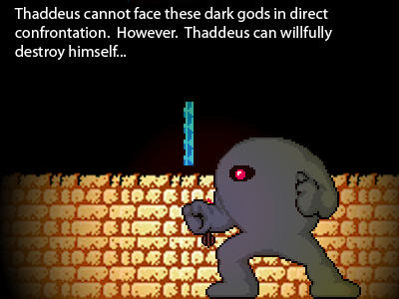*

*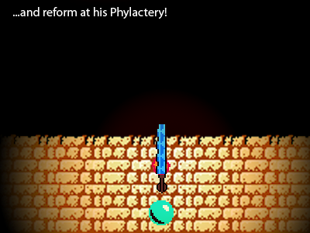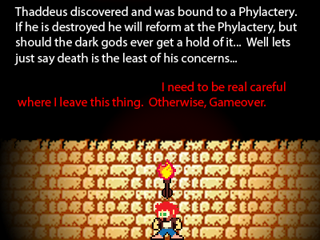*

*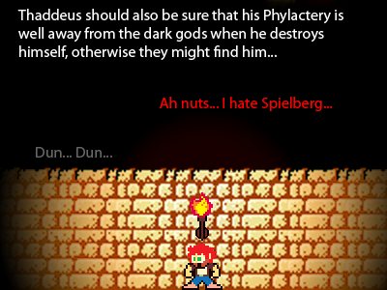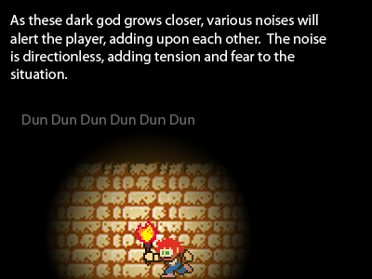*

*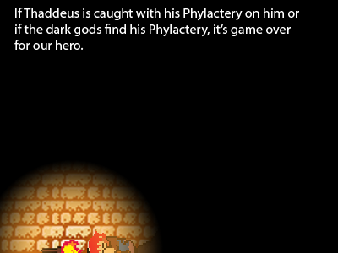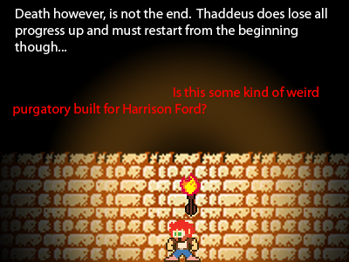*

*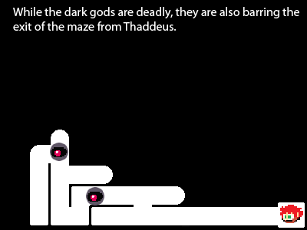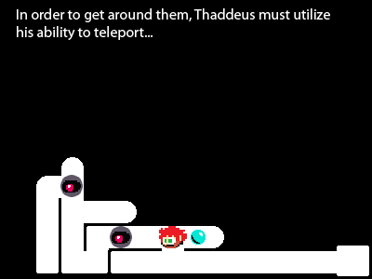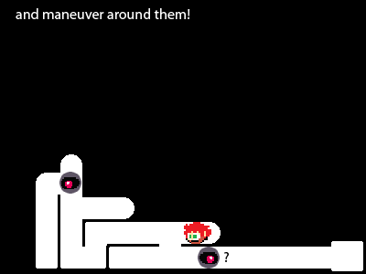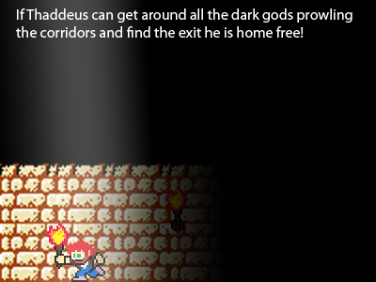*

1. Detailed Game Description
   1. Basic Concept

The player is set in a maze and must, through dying, lure the monsters out of the way so he can escape.

* 1. What is the game genre?

Survival Horror, Exploration and Dungeon Crawler.

* 1. Background Story

On the outskirts of Gortnaskagh, Ireland, a cult has recently formed due to a rash of mysterious, sinister accidents. They attribute the accidents to powers that existed before man asserted dominance over Cro-Magnon, powers that have manipulated human history in subtle ways to draw us to their side. These powers, the cultists say, are no longer amused by simple torments. They crave supremacy.

While none but the cultists know the source of their information, it is evident that they are putting it to use. They have constructed, by shovel and pick, a giant focus for these Outside powers. This maze allows the tools of these destructive forces to work directly in our world, rather than simply whispering into our minds.

Word of this cult reached Thaddeus Doyle, a self-styled Righter of Wrongs and champion of the people. He proclaimed his intent to stop them. They responded with force, abducting him as he arrived in town.

Helpless, Thaddeus could do nothing as they bound his soul to a phylactery--a gem that reforms his body upon his death. The cultists intend to sacrifice Thaddeus to their dark masters--not once, but forever.

* 1. What is the “tone” of the game?

Dark, Claustrophobic, Desperate, Paranoid and Suspenseful.

* 1. What is the basic narrative?

The story itself is delivered by gameplay with the exception of the backstory, which is given (really just to establish the whos and whys) by the Phylactery.

* 1. What is the game’s objective?

Escape the maze with the phylactery.

* 1. Describe the gameplay in detail

Start the game, begins the game immediately by starting the introduction.

Game’s first scene is an introduction, where Thaddeus is stuck in the maze and given a short monologue on his current state. The monologue should give a short introduction of the game mechanics.

The AI is fairly straight-forward, going along patrol routes within the maze, and reacting to the player’s presence by chasing after him, and in the case of the Faded, even through walls, while the bonewheel does not chase the player.

The player must thus run away and use his teleport mechanic to escape the patrols. The player also has the capability to use a map showing the lit portions that he has explored, but must use it carefully because he is not aware of his environment around him while viewing his map.

The user can, for example, upon finding a fork in the maze, place his phylactery at the fork and explore one section. Upon finding a patrol along that route, he teleports back to the fort and tries the other section.

* 1. Describe the interface(s).

Player switches between first-person view and viewing his map. A general idea for the map was given in the pictures above, while the first-person view has no UI, only what can be seen realistically.

* 1. What is the planned perspective?

First-person while moving and third-person far overhead when viewing the map.

* 1. What is the "heart" of the gameplay?

The heart of the gameplay is exploration. The heart of the game plays off the feelings of anxiety and fear created through hostile encounters with creatures that far overpower the player to provide a memorable and enjoyable game play experience.

* 1. Describe the multiplayer game, if applicable.

There is no multiplayer.

* 1. How difficult is the game?

The average player is expected to fail several times before completing the level as they learn to deal with the various monster AI patterns and learn the maze.

* 1. How long will it take a player to complete the level?

Ideally 20-30 minutes would be the average play time, 10-15 if they can get it in the first go.

1. Other Aspects of the Game
   1. Characters

The player plays as Thaddeus Doyle, a gentleman adventurer who’s been pulled into a hellish trap by worshipers of dark, ancient, vaguely Lovecraftian powers. He’s used to stand-up fights and being able to intimidate his foes with his heroic guffaw. Facing things-man-was-not-meant-to-guffaw-at has weakened his confidence, as has dying repeatedly to manipulate his opponents and the ever-present threat of the Great Evils getting ahold of his phylactery leaving him a tortured plaything of things-man-was-not-meant-to-taunt-or-hyphenate.  
  
The cultist that binds Thaddeus’s soul to the phylactery is an obsessed individual who desires nothing more but to serve the dark inhabitants of the maze. Shortly after binding a helpless Thaddeus to the phylactery, he offers himself as a sacrifice (since his work dooming Thaddeus is done). This shows the player the precise danger of the maze’s monsters.

The only other characters Thaddeus meets within the scope of the stage are the monsters themselves. These creatures were humans who willingly transformed themselves into vessels for their abyssal masters.

There are a few types of these creatures. The majority of them turned into the Eaters, gelatinous shamblers of vaguely human shape, their mostly transparent forms filled with swirls of blood. The sole exception is their jaws—the Eaters retain the jaws of their original human forms, but they do not use them. Should they ever capture Thaddeus, they will simply flow over him, suffocating him, allowing the player to listen to Thaddeus fighting to scream as his every orifice is filled with foul essence from beyond our plane. Once he has been slain, Eaters will content themselves slowly dissolving his corpse into more mass for their forms. The player can recognize locations where Eaters patrol by the thick bloody ooze trail they leave behind them, and the rhythmic sound of thick jello being smacked on pavement.

A swifter breed of creature can be found in the maze in the form of the Bonewheels. These creatures can be heard from farther off than Eaters—their loud clacking echoing well in the tight confines of Thaddeus’s soon-to-be tomb. The clacking is generated by the dozens of bony hands that form the rim of the Bonewheels’ prominent wheels, six feet in radius and roughly ten feet apart. From the axel of these two wheels hang the Bonewheel’s maw, a gaping assembly of serrated steel spikes. It is this maw that does the Bonewheel’s gruesome work. The first blow is always a ramming charge, aimed at the ribcage’s gaps. This usually kills the victim, but the unfortunate ones keep their awareness as the Bonewheel stabs its dexterous hooks into its victim’s body, twisting, tearing the flesh off to get at the bones. This bloody work starts at the ends—the feet and the hands first, then the shins and the forearms, then the upper arms, thighs and head, then the torso and neck. Once the bones have been flayed, it stores them in a cage on its back to weave into new Bonewheels later.

As dangerous as Bonewheels and Eaters may be, they lack the persistence that works to Thaddeus’s advantage in evading them and continuing onward in the maze. This is not so with the Fated. These green gaseous creatures have no form save for a pair of bright green yellow eyes, which emit the gas. This gas rapidly spreads and billows with no wind, but gases separated from the eyes fade and dissipate. Fated keep quiet in their hunts, at most a quiet hissing preludes their toxic assaults. They can be detected ahead of time, though, by the fact that the gas is extremely flammable and burns a bright sickly green. The Fated gaze is paralyzing at short range. Once they’ve paralyzed their victims, the Fated eyes burrow into the eye sockets and set the body on fire, burning it into green smoke. Ordinarily, they then pull out the soul through the nose and consume it. However, Thaddeus’s soul is bound to the phylactery. This denies the Fated its meal, aggravating it. It will then pursue Thaddeus with greater determination.

* 1. Multi-Player Characters

No multiplayer.

* 1. World/Map

The entire game (with the exception of the final escape) takes place within The Maze. This is a recent labyrinth constructed by the cult that serves as a magical bind for the monsters, allowing them to exist. It is here that Thaddeus is taken, it is here that Thaddeus is bound to the phylactery, and it is here that Thaddeus dies, dies, and dies again. The final escape brings the character out of the maze into the light of late evening. The cultists guarding the front door are the final obstacle, but after running from otherworldly demons so long, Thaddeus jumps into the fight with both fists swinging and wins. The light of the sun dissolves the phylactery, and Thaddeus is freed.

* 1. Controls  
     Movement:

WASD/ARROW KEYS – Move forward, backward, strafe left, strafe like.

Mouse – Looking around, turning

Left Click – Interact with the menu

E – Place Phylactery

K – Die ( and reform at Phylactery)

Tab – Press to toggle at mini-map

* 1. Describe the on-screen interface

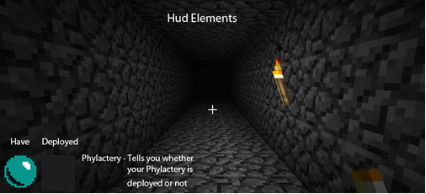

The only constant onscreen HUD element (of sorts) is the player’s phylactery. The phylactery’s model is carried in front of the character’s view, so if they have it and they haven’t left it in the maze, they can see it. If the player pauses the game, they’re brought to the Pause menu. If the player presses Tab (or their bind) and zooms out to the minimap view, the minimap is not actually a HUD element—just a distant top-down view of the maze. The player has no HP system—if the player is caught, they are killed. If a monster has collected Thaddeus’s phylactery, he’ll be able to run around for his current life, but the instant he’s caught, it’s a full game over. Apart from that, all information is conveyed to the player entirely through the environment—the bloody, oily slicks of Eater paths, the clacking of patrolling Bonewheels and the pale green light of the Fated’s gas burning tell the player where enemies are. Mounts for torches are visible on the walls.

* 1. Menus

Main Menu

* + - * Start Game
      * Options

Opens Options Menu

* + - * Exit Game

Options Menu

* + - * Volume (0% - 100% slider)
      * Brightness (0% - 100% slider)
      * Subtitles (Y/N)
      * Bind Menu

Opens bind menu

* + - * Cancel (undoes changes and returns to previous menu)
      * Accept (keeps changes and returns to previous menu)

Binds Menu

* + - * Move Forward (default W)
      * Move Backward (default S)
      * Strafe Left (default A)
      * Strafe Right (default D)
      * Look (axes)
      * Interact (place torch / push button / etc.) (default F)
      * Drop Phylactery (default E)
      * Commit Suicide (default K)
      * Open Map (default tab)
      * Cancel (undoes changes and returns to Options menu)
      * Accept (keeps changes and returns to Options menu)

Pause Menu

* + - * Options
      * Quit Game
  1. Text Messages

There will be no explicit text messages on screen, unless the player is playing the game in Subtitled mode. If the player is playing in Subtitled mode, sound queues that would let the player know about the presence of creatures would be displayed on the screen, with positioning based on the relative sound level between the left and right speaker. Quieter sounds would have smaller text or lower alpha to make it harder to read, while louder sounds would be bolder or clearer.

* 1. Graphics

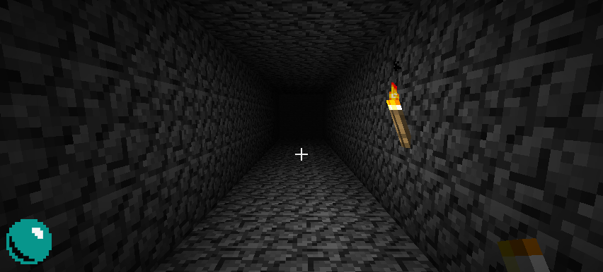  
Graphically, Rout will have a very simplistic tiled feel, much like mine craft. Most of the creatures will be simple, one pretty much a smoke effect with two balls of light. Thaddeus, the players character model will also be simple because he will rarely be seen besides a hand holding a torch and the top of his head on the overhead view.

1. Images and Sounds – DOES NOT COUNT TOWARD 10 PAGE MINIMUM
   1. Character Art

Thaddeus Doyle:

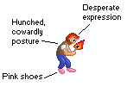

The Bone-Wheel:

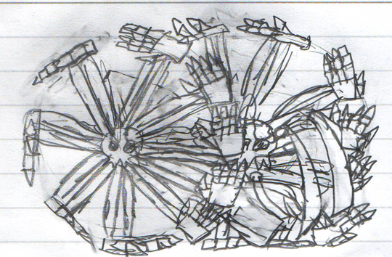

The Eater:

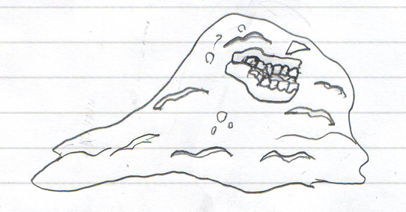

The Faded:

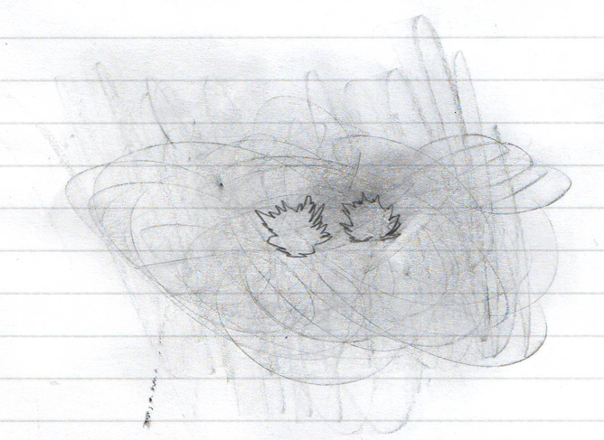

* 1. Interface Images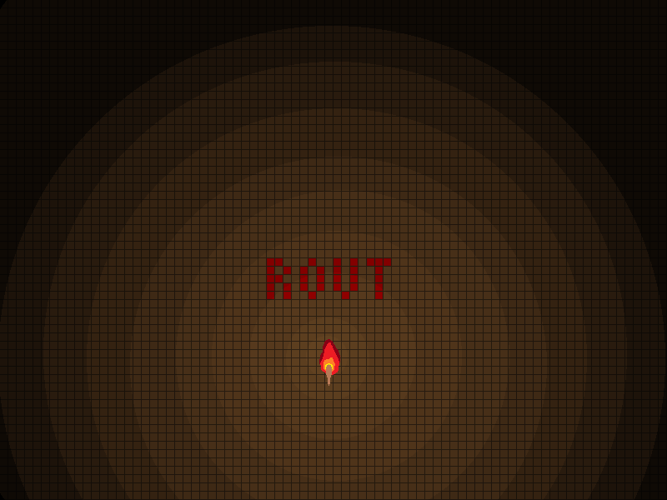
  2. Sounds and Music

Sounds

* + - * Footfalls (Player’s boots)
      * Death Screams (at least 5)
      * Torch Crackling
      * Torch Placing (wood on metal sliding)
      * Slime Slithering Noises
      * Suffocation Gasps (at least 3)
      * Bone Clacking On Stone
      * Gas Hissing
      * Clink for Dropped Phylactery

Music

* + - * 3 atmospheric tracks of varying levels of tension (crossfaded as the tension level in the game changes)

1. References

Minecraft for the screenies and Megaman for sprites for the comic narration.